

Properties and Structures of Atoms

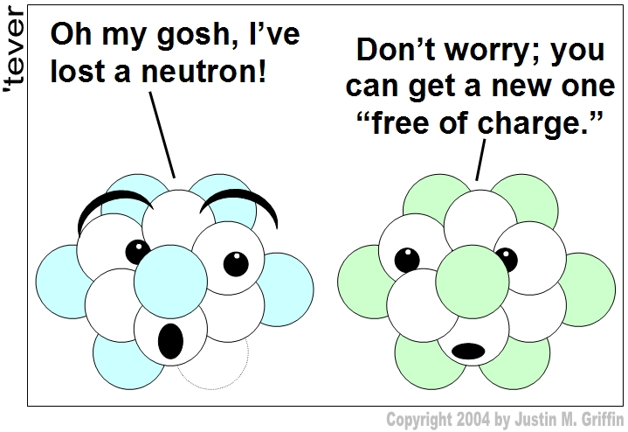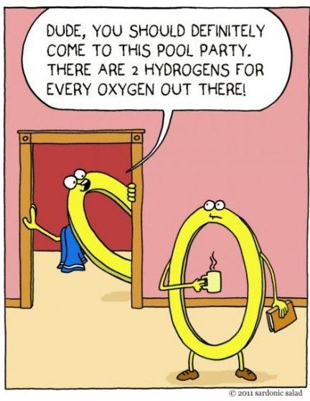

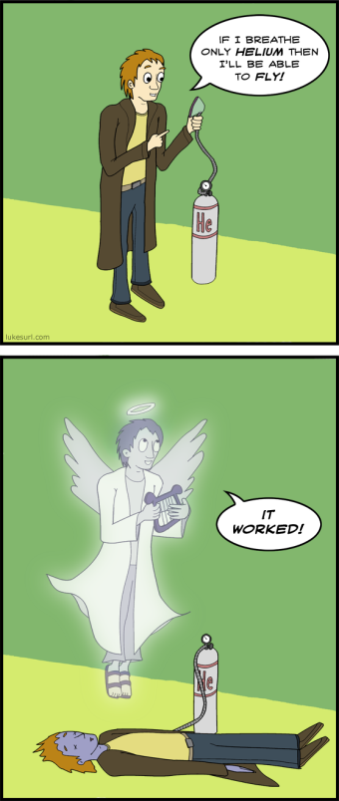 (lol-rofl.com 2014)

(Yiyang 2013)

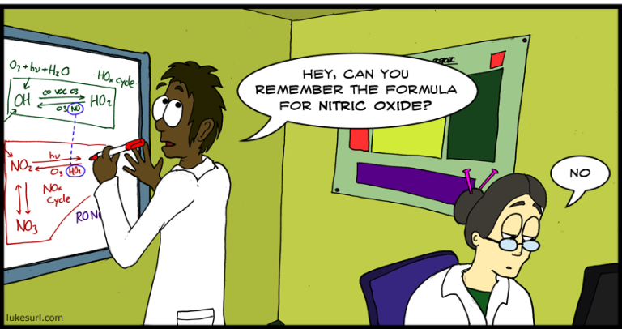

(Surl, Posts Tagged Chemistry 2010)

(Surl, Posts Tagged Chemistry 2011)

|  |  |  |  |
| --- | --- | --- | --- |
| **Week** | **Outcomes** | **References** | **Tasks** |
| **1** | * elements are represented by symbols * atoms can be modelled as a nucleus, surrounded by electrons in distinct energy levels, held together by electrostatic forces of attraction between the nucleus and electrons; the location of electrons within atoms can be represented using electron configurations * isotopes are atoms of an element with the same number of protons but different numbers of neutrons and are represented in the form A X (IUPAC) or X-A * isotopes of an element have the same electron configuration and possess similar chemical properties but have different physical properties * the relative atomic mass (atomic weight), Ar is the ratio of the average mass of the atom to 1/12 the mass of an atom of 12C; relative atomic masses of the elements are calculated from their isotopic composition * mass spectrometry involves the ionisation of substances and the separation and detection of the resulting ions; the spectra which are generated can be analysed to determine the isotopic composition of elements and interpreted to determine relative atomic mass | Lucarelli p 6-8  Set 2(p9) q 6-16 |  |
| 2 | * Findings from a range of scientific experiments contributed to the understanding of the atom, enabling scientists, including Dalton, Thomson, Rutherford, Bohr and Chadwick to develop models of atomic structure and make reliable predictions about the mass, charge and location of the sub-atomic particles. * flame tests and atomic absorption spectroscopy (AAS) are analytical techniques that can be used to identify elements; these methods rely on electron transfer between atomic energy levels and are shown by line spectra | Lucarelli p11-19  Set 3 (p19) q1-12  Flame tests  Exploring Chemistry (p 28)  Spectroscopes | **Task 1:** ER  Discovery of the atom |
| 3 | * molecular formulae represent the number and type of atoms present in the molecules * percentage composition of a compound can be calculated from the relative atomic masses of the elements in the compound and the formula of the compound (empirical formula using percentage composition) | Lucarelli p27-30  Set 5(p30) q1-15c |  |
| 4 | * the ability of atoms to form chemical bonds can be explained by the arrangement of electrons in the atom and in particular by the stability of the valence electron shell * the structure of the periodic table is based on the atomic number and the properties of the elements * the elements of the periodic table show trends across periods and down main groups, including in atomic radii, valencies, 1st ionisation energy and electronegativity as exemplified by groups 1, 2, 13–18 and period 3 | Lucarelli p47-49  Set 9(p50) q1-12  Lucarelli p70-73  Set 15(p74) q1-11 | **Task 2:** Test  Properties and structure of atom |

References

Davis, A. *Nelson Chemistry Units 1 & 2.* South Melbourne: Cengage Learning Australia Pty Limited, 2014.

Lucarelli, N. *ESSENTIAL CHEMISTRY Australian Curriculum for WA ATAR Chemistry Units 1 + 2.* Willetton: Lucas Publications, 2014.

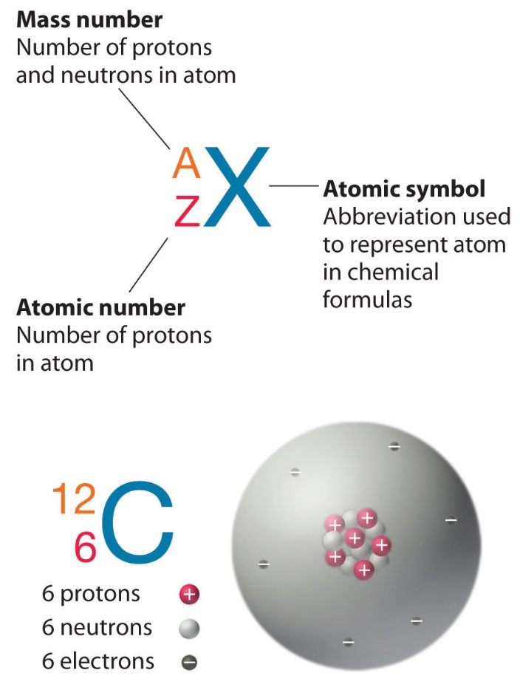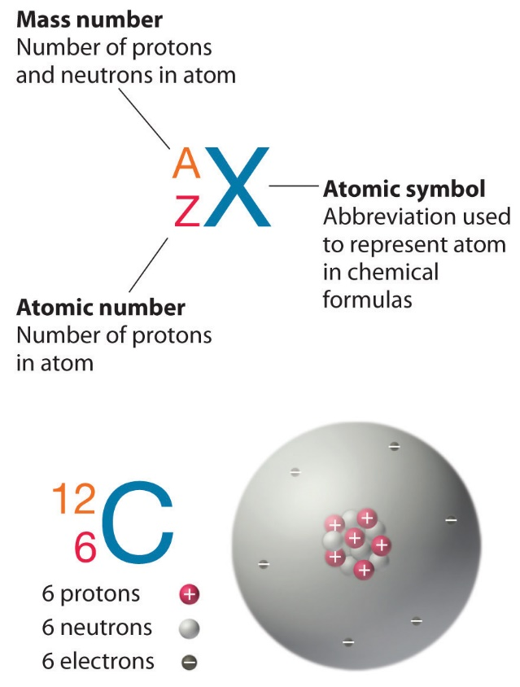

Draw a simple, labelled diagram of a fluorine atom that contains 9 protons, 10 neutrons and 9 electrons.

Complete the following table. An example has been done for you.

|  |  |  |  |  |  |
| --- | --- | --- | --- | --- | --- |
| Element | Mass number | Atomic number | Protons | Neutrons | Electrons |
|  | 12 | 6 | 6 | 6 | 6 |
|  |  |  |  |  |  |
|  |  |  |  |  |  |
|  |  |  |  |  |  |
|  |  |  |  |  |  |
|  |  |  |  |  |  |
|  |  |  |  |  |  |
|  | 80 |  | 35 |  | 35 |
|  |  | 27 |  | 32 | 25 |
|  |  |  |  |  |  |
|  |  |  | 16 | 16 | 18 |

**Isotopes**

Atoms of the **same element** (same atomic number/ same number of protons) but with **different numbers of neutrons.**

|  |  |  |  |
| --- | --- | --- | --- |
| **Isotope** | **Number of protons**  **(Atomic Number)** | **Number of neutrons** | **Mass number** |
|  |  |  |  |
|  | **6** |  | **13** |
|  | **6** | **8** |  |
| **Cl- 35** |  |  |  |
| **Cl- 37** |  |  |  |
|  | **1** | **0** |  |
|  | **1** | **1** |  |
|  | **1** | **2** |  |

**Ions**

Charged atoms or group of atoms formed by the **gain** or **loss** of **electrons.**

* **Anion**: negatively charged ion formed by the gain of electrons.
* **Cation**: positively charged ion formed by the loss of electrons.

|  |  |  |  |  |  |  |
| --- | --- | --- | --- | --- | --- | --- |
|  | **Species** | **Cation/Anion** | **Atomic number**  **(number of protons)** | **Number of electrons** | **Number of neutrons** | **Mass number**  **(number of protons + neutrons)** |
| a) |  |  | 13 |  |  |  |
| b) |  |  |  | 18 | 16 | 31 |
| c) |  |  | 17 | 18 | 18 |  |
| d) |  |  | 3 | 2 |  | 7 |
| e) |  |  |  |  | 8 |  |
| f) |  |  |  |  | 8 |  |
| g) |  |  | 18 | 18 | 22 |  |
| h) | Charge of 2+ |  |  | 10 |  | 24 |

**Relative mass**

This is the mass of a particle compared to the mass of an atom of the carbon- 12 isotope.

* The relative mass has no units.
* For atoms it is the same as the relative atomic mass (Ar)
* For molecules and ionic compounds, it is found by adding up all the individual relative atomic masses of the component atoms.

Eg. The relative atomic mass of Mg is ______________

The relative molecular mass of CO2 is ____________________________________

The relative formula mass of NaCl is _____________________________________

**Energy Levels (Electron Shells): Key ideas**

* Electrons are located in distinct energy levels around the nucleus.
* Energy levels are numbered 1, 2, 3, 4, etc from closest to the nucleus outwards.
* Each energy level can hold a maximum of 2n2 electrons where n is the energy level.
* Energy-wise, it is not efficient to fill each energy level completely before moving onto the next level. This does occur in the first two energy levels but from then on, it follows the following order:

|  |  |  |  |  |  |  |
| --- | --- | --- | --- | --- | --- | --- |
|  | **Energy Level and Maximum Occupancy with Arrows Showing Filling Sequence** | | | | | |
| **Number of Electrons** | **1** | **2** | **3** | **4** | **5** | **6** |
| **Up to 20** | 2 then | 8 then | 8 then | 2 then |  |  |
| **21 – 38** |  |  | 18 then | 8 then | 2 then |  |
| **39 – 56** |  |  |  | 18 then | 8 then | 2 |

Write the electron configurations for the following species and draw the Lewis structure.

|  |  |
| --- | --- |
| Na | P |
| Cr | Br |
| K+ | Ar |
| Mn2+ | N3- |
| Ba2+ | I‒ |
| Ca | Ag |
| S2- | Al3+ |
| Cu+ |  |

**Arrangement of elements in the periodic table.**

The number of valence electrons an atom has determines its group (vertical column) in the periodic table.

The number of electron shells (energy levels) an atom has determines its period (horizontal row) in the periodic table.

**Example:** Magnesium has two valence electrons and is in group 2.

Magnesium has three electron shells (energy levels) and is in period 3.

**Valence Electrons and Chemical Properties**

* The arrangement of electrons (in particular the valence electrons) can explain the bonding capacity of an element as well as some of its chemical properties.
* When gaining, losing or sharing electrons, the elements will tend to try to attain the electron configuration of their nearest noble gas. Noble gases have full valence shells (sometimes referred to as achieving a stable octet, except for He that only has two electrons)
* Group 1 – readily lose one electron to form cations with charge of +1. Are highly reactive.
* Group 2 – lose two electrons to form cations with charge of +2. Are less reactive than Group 1.
* Group 13 – lose three electrons.
* Group 14 – tend to share four electrons and usually have a bonding capacity of four.
* Group 15 – gain three electrons (forming an anion with a charge of -3) or can share three electrons and usually have a bonding capacity of three.
* Group 16 – gain two electrons (forming an anion with a charge of -2) or can share two electrons and usually have a bonding capacity of two.
* Group 17 – gain one electron (forming an anion with a charge of -1) or can share one electron and usually have a bonding capacity of one.

**Ground state –** electrons are in their lowest energy level.

**Excited state –** electrons gain a specific amount of energy and move to a higher energy level. As this state is unstable, the electron will return to its ground state and in doing so it releases the specific amount of energy it gained. It releases this energy in the form of a photon (light). These photons have a specific wavelength that corresponds to a particular colour of light.

**Emission and absorption spectra**

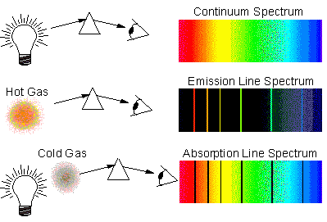

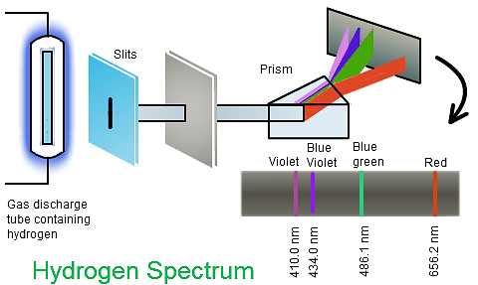

(NCS Pearson 2014)

Naming and formulae writing for ionic compounds**:**

* **Use** ions table
* Do **not** use mono, di, tri etc

|  |  |
| --- | --- |
| **Name** | **Formula** |
| Potassium chloride |  |
| Magnesium chloride |  |
| Aluminium chloride |  |
| Sodium nitrate |  |
| Sodium carbonate |  |
| Sodium phosphate |  |
| Calcium nitrite |  |
| Calcium nitrate |  |
| Calcium nitride |  |
| Zinc sulphite |  |
| Zinc sulphate |  |
| Zinc sulphide |  |
| Iron (II) oxide |  |
| Iron (III) oxide |  |
| Copper (I) hydroxide |  |
| Copper (II) hydroxide |  |
| Ammonium nitrate |  |
| Ammonium iodide |  |
| Ammonium sulphate |  |
|  | AgCl |
|  | AgCH3COO |
|  | Ag2O |
|  | MgO |
|  | Mg3(PO4)2 |
|  | SnCO3 |
|  | SnCl4 |
|  | NaHCO3 |
|  | Ba(CH3COO)2 |

Naming and formulae writing for covalent compounds:

* Do not use ions table
* Use mono, di, tri, tetra, penta, hexa, hepta, octa, nona, deca

|  |  |
| --- | --- |
| **Name** | **Formula** |
|  | SO2 |
|  | SO3 |
| Carbon monoxide |  |
| Carbon dioxide |  |
| Trisulfur octaoxide |  |
|  | P2F6 |
|  | N2O5 |
|  | N2O3 |

**Atomic absorption spectroscopy (AAS)**

This is a quantitative method of determining the concentration of a particular element (typically a metal) in a mixture.

A solution of the sample is atomised in a hot flame. A beam of light from a **hollow cathode lamp** (made from the metal being analysed so that the wavelength of the light produced is of the exact wavelength to be absorbed by the metal) is passed through the sample. The non-absorbed light then passes through a slit to focus it before it enters a monochromator (which selects one particular wavelength to be analysed). The light is then analysed by a detector which measures the intensity of the light and determines the degree to which the light has been absorbed (absorbance). The absorbance is proportional to the concentration of the metal ion in the flame. A calibration curve (prepared using solutions of the metal in known concentrations) can then be used to determine the concentration of the metal ion in the unknown sample.

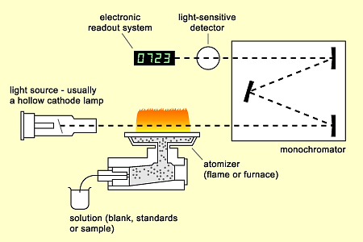

(NA nd)

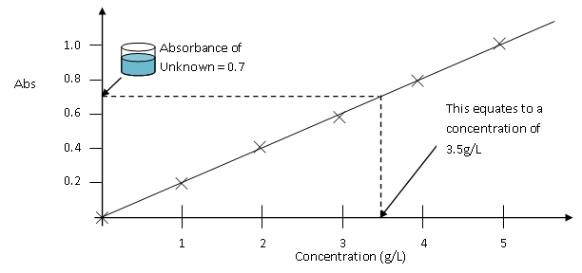

(The University of Queensland 2014)

**Mass spectrometry**

Mass spectrometry can be used to determine the identity of compounds or elements in a sample or to determine the isotopic composition of an element

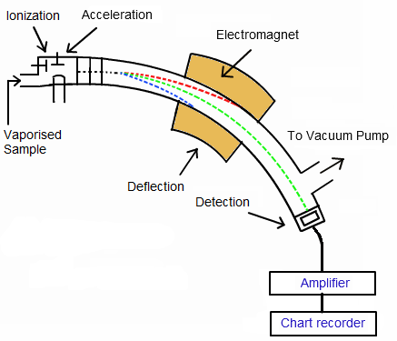

**Five main processes involved in mass spectrometry:**

* Vaporisation – sample is made gaseous in a vacuum chamber
* Ionisation – gaseous sample is bombarded by electrons which causes it to form ions (mostly +1 but some +2)
* Acceleration – ions are accelerated through an electric field
* Deflection -ions then move into a magnetic field where they are deflected based on their mass to charge ratio; heavier ions are deflected less.
* Detection – detector measures the number of ions of different mass (based on intensity and radius of deflection of ions)

(NCS Pearson 2014)

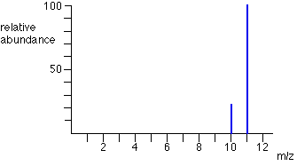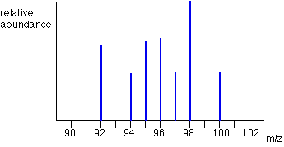

Mass spectrum of boron (Clark, The Mass Spectra of Elements 2000) Mass spectrum of molybdenum (Clark, The Mass Spectrometer 2000)

Example 1. Naturally occurring boron occurs as 80.2% 11B and 19.8% 10B. Calculate the relative atomic mass of naturally occurring boron.

Example 2. Naturally occurring copper has a relative atomic mass of 63.55 and consists of 63Cu and 65Cu. Calculate the relative abundance of each isotope.

Example 3. Determine the relative atomic mass of chromium using the mass spectra below (assume the signal is percentage abundance).

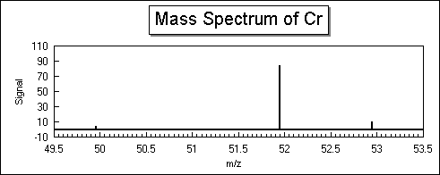

(N.A. nd)

Example 4. Calculate the **percentage composition** of each element in acetic acid (CH3COOH).

Example 5. 15.0 g of an oxide of vanadium contained 10.2 g of vanadium. Calculate the **percentage composition** of oxygen and vanadium in the sample.

**Empirical Formula**

Empirical formula is the simplest whole number ratio of elements in a particular compound. Molecular formula is the actual whole number ratio of elements in a particular compound.

|  |  |
| --- | --- |
| Molecular Formula | Empirical Formula |
| H2O | H2O |
| H2O2 | HO |
| C4H6O2 | C2H3O |
| NaCO3* | NaCO3 |

* Not actually a molecular formula (as it is ionic)

Empirical formulae can be determined experimentally by calculating the percentage composition and then applying this to the mole ratio of particles.

Eg Calculate the empirical formula of the compound that contains 62.5% Pb, 8.50% N and 29.0% O.

|  |  |  |  |
| --- | --- | --- | --- |
|  | **Pb** | **N** | **O** |
| **%** | 62.5 | 8.50 | 29.0 |
| **m in100g (g)** | 62.5 | 8.50 | 29.0 |
| **n (mol)** |  |  |  |
| **ratio** |  |  |  |
| **≈** | 1.00 | 2.01 | 6.01 |
| **round** | 1 | 2 | 6 |

∴empirical formula = PbN2O6 (or Pb(NO3)2)

Example 6. Determine the empirical formula of a compound that contains by mass 43.4% Na, 11.3% C and the remaining oxygen.

**Atomic radius**

________________________________________________________________________________________________________________________________________________________________________________________________________________________________________________________________________________________________________________________

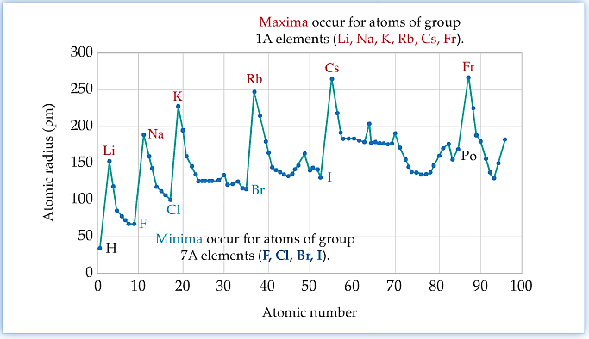

**Ionisation energy**

______________________________________________________________________________________________________________________________________________________________________________________________________________________________________________________________________________________________________________________________________________________________________________________________________

**Electronegativity**

______________________________________________________________________________________________________________________________________________________________________________________________________________________________________________________________________________________________________________________________________________________________________________________________________

# Bibliography

Clark, J. 2000. *The Mass Spectra of Elements.* Accessed December 4, 2014. http://www.chemguide.co.uk/analysis/masspec/elements.html#top.

—. 2000. *The Mass Spectrometer.* Accessed December 4, 2014. http://www.chemguide.co.uk/analysis/masspec/howitworks.html.

Emsley, J. 1998. *Periodic Trends Atomic and Ionic Radii.* Accessed December 2, 2014. http://www.angelo.edu/faculty/kboudrea/periodic/trends_atomicradius.htm.

lol-rofl.com. 2014. *Chemistry Cartoon.* Accessed December 2, 2014. http://lol-rofl.com/chemistry-cartoon/.

N, Lucarelli. 2014. *ESSENTIAL CHEMISTRY Australian Curriculum for WA ATAR Chemistry Units 1 + 2.* Willetton: Lucas Publications.

N.A. nd. *Atoms and Elements Problem Set.* Accessed December 9, 2014. http://donkistry.tripod.com/hw2.htm.

NA. nd. *Task 2 AAS Instrumentation.* Accessed December 1, 2014. https://nationalvetcontent.edu.au/alfresco/d/d/workspace/SpacesStore/1bdfdbc3-2875-4457-b872-40aa14d6b193/508/PMLTEST506/42step01.htm.

NCS Pearson. 2014. *Biomolecules.* Accessed December 4, 2014. http://chemistry.tutorvista.com/analytical-chemistry/biomolecules.html.

—. 2014. *Spectral Lines.* Accessed December 1, 2014. http://chemistry.tutorvista.com/inorganic-chemistry/spectral-lines.html.

Surl, L. 2010. *Posts Tagged Chemistry.* Accessed December 2, 2014. http://www.lukesurl.com/tags/chemistry.

—. 2011. *Posts Tagged Chemistry.* Accessed December 2, 2014. http://www.lukesurl.com/tags/chemistry.

The University of Queensland. 2014. *Spectrophotometry.* Accessed December 1, 2014. http://www.di.uq.edu.au/sparqspectro.

Warwick Public Schools. 2006. *Honors Chemistry Online Text.* Accessed December 2, 2014. http://webmail.warwickschools.org/~bizraganem/?OpenItemURL=S007217CD.

Yiyang, X. 2013. *Funny Physics and Chemistry Cartoons.* Accessed December 2, 20141. http://lurqn.com/funny-physics-and-chemistry-cartoons/.